|  |  |
| --- | --- |
| Name : Cabacaba, Mike Leanard V. | Section : BSIT 3C |
| Assignment No : 2 | Submission Date : 03, 023, 2024 |
| Assignment Title: Rock - Paper - Scissors | |

**Code :**

**HTML FILE**

<!DOCTYPE html>

<html>

<head>

<meta name="viewport" content="width=device-width, initial-scale=1.0">

<title>Rock - Paper - Scissors</title>

<link rel="stylesheet" href="index.css">

</head>

<body>

    <h1>Rock - Paper - Scissors</h1>

    <div class="choices">

        <button onclick="playGame('rock')">👊</button>

        <button onclick="playGame('paper')">✋</button>

        <button onclick="playGame('scissors')">✌️</button>

    </div>

    <div id="playerDisplay">Player: </div>

    <div id="computerDisplay">Computer: </div>

    <div id="resultDisplay">

    </div>

    <div class="scoreDisplay">

        Player Score: <span id="playerScoreDisplay">0</span>

    </div>

    <div class="scoreDisplay">

        Computer Score: <span id="computerScoreDisplay">0</span>

    </div>

</body>

<script src="index.js"></script>

</html>

**JS FILE**

const choices=["rock","paper","scissors"];

const playerDisplay = document.getElementById("playerDisplay");

const computerDisplay = document.getElementById("computerDisplay");

const resultDisplay = document.getElementById("resultDisplay");

const playerScoreDisplay = document.getElementById("playerScoreDisplay");

const computerScoreDisplay = document.getElementById("computerScoreDisplay");

let playerScore = 0;

let computerScore = 0;

function playGame(playerChoice){

    const computerChoice = choices[Math.floor(Math.random()*3)];

    let result="";

    if(playerChoice===computerChoice){

        result ="IT'S A TIE";

    }

    else{

        switch(playerChoice){

            case"rock":

            result=(computerChoice==="scissors")? "YOU WIN!" : "YOU LOSE!";

            break;

            case"paper":

            result=(computerChoice==="rock")? "YOU WIN!" : "YOU LOSE!";

            break;

            case"scissors":

            result=(computerChoice==="paper")? "YOU WIN!" : "YOU LOSE!";

            break;

        }

    }

    playerDisplay.textContent = `PLAYER: ${playerChoice}`;

    computerDisplay.textContent = `COMPUTER: ${computerChoice}`;

    resultDisplay.textContent = result;

    resultDisplay.classList.remove("greenText","redText")

    switch(result){

        case "YOU WIN!":

            resultDisplay.classList.add("greenText");

            playerScore++;

            playerScoreDisplay.textContent = playerScore;

            break;

        case "YOU LOSE!":

            resultDisplay.classList.add("redText");

            computerScore++;

            computerScoreDisplay.textContent = computerScore;

            break;

    }

}

**CSS FILE**

body{

    font-family: Arial, sans-serif;

    font-weight: bold;

    margin: 0;

    display: flex;

    flex-direction: column;

    align-items: center;

}

h1{

    font-size: 3.5rem;

    color: hsl(0, 0%, 20%);

}

.choices{

    margin-bottom: 30px;

}

.choices button{

    font-size: 7.5rem;

    min-width: 160px;

    margin: 0 10px;

    border-radius: 250px;

    background-color: hsl(200, 100%, 50%);

    cursor: pointer;

    transition: background-color 0.5s ease;

}

.choices button:hover{

    background-color: hsl(200, 100%, 70%);

}

#playerDisplay, #computerDisplay{

    font-size: 2.5rem;

}

#resultDisplay{

    font-size: 5rem;

    margin:30px 0;

}

.scoreDisplay{

    font-size: 2.5rem;

}

.greenText, #playerScoreDisplay{

    color:hsl(130, 84%, 54%);

}

.redText, #computerScoreDisplay{

    color:hsl(0, 84%, 60%);

}

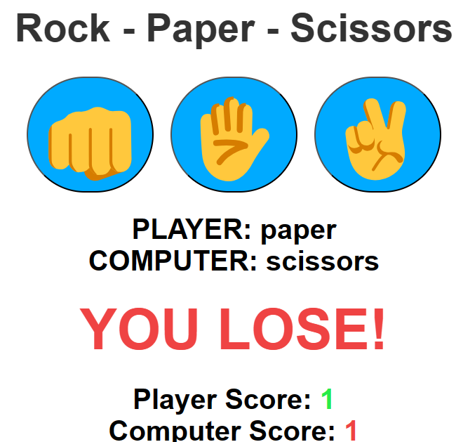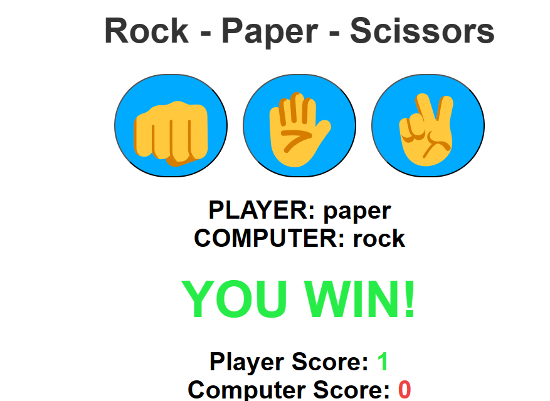**SCREENSHOT**

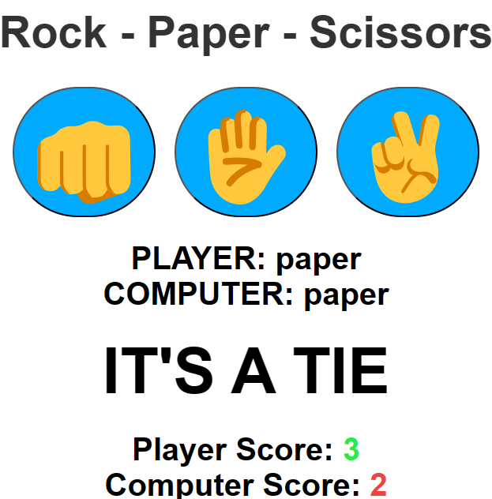

**Dictionary:**

*// List keywords, tags, or methods that are new to you and explain how they are used in the code.*

*// atleast 5 tag, methods or keyword  
  
Example :*

* textContent – return text of an element.

**Syntax**: sampleDisplay.textContent = sample;

**Parameter:** sample(variable,string);

console.log(playerDisplay.textContent = "sample");

output: sample.

* ++ - increment.

**Syntax** : num++.

**Parameter**: num(integers)

console.log(10++)

Output : 11

* classList.add – add classes of an element

**Syntax** - resultDisplay.classList.add("greenText ");

**Parameter**: strings.

resultDisplay.classList.add("greenText ");

output: YOU WIN!

* classList.remove - remove classes of an element

**Syntax -** resultDisplay.classList.remove("greenText ");

**Parameter**: strings.

resultDisplay.classList.remove("greenText ");

output: IT’S A TIE

* hsl – (hue, saturation, lightness) is a color model used in CSS to define colors.

**Syntax**: color:hsl(130, 84%, 54%);

**Parameters:** H – Hue S – Saturation L-Lightness

color:hsl(130, 84%, 54%);

output: YOU WIN!;